Offices location map
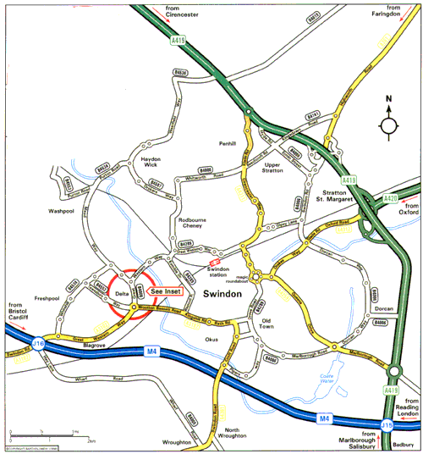
Leave the M4 at junction 16 and follow the dual carriageway towards Swindon. Go straight over the next two roundabouts you encounter, and approximately 0.25 miles after the second roundabout, turn left into Delta Business Park. Take the next left, which is before the large mirrored building belonging to Intergraph. Follow the road until you reach the Ibis Hotel. PwC Kinesis Ltd entrance is in the corner building to your right.
See Inset Detail on next page:

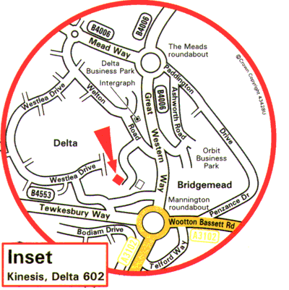

PricewaterhouseCoopers Kinesis Limited
Delta 602
Delta Business Park
Swindon
Wiltshire
SN5 7XJ
Telephone: +44 (0)1793 536291
Fax: +44 (0)1793 529641

